ForgetMeNot
Final Year Project Proposal
Session 2025-2026

A project submitted in partial fulfillment of the
COMSATS University Degree
of
BS in Artificial Intelligence (CUI)



Department of Computer Science
COMSATS University Islamabad, Lahore Campus

Date: 08 October 2025
Project Registration
Project ID (for office use)
Type of project |  |  | [✓] Traditional [ ] Industrial [ ] Continuing
Nature of project |  |  | [ ] Development [✓] Research & Development
Sustainable Development Goals(SDGs) |  |  | [✓] Good Health and Well-Being [ ] Quality Education  [ ] Industry, Innovation, and Infrastructure [ ] Gender Equality  [ ] Decent Work and Economic Growth [ ] Climate Action
Area of specialization |  |  | [✓] Artificial Intelligence (AI) [ ] Blockchain [ ] Cybersecurity  [ ] Data Science and Analytics [ ] Game Development  [ ] Internet of Things (IoT) [ ] Natural Language Processing (NLP)  [✓] Mobile App Development [ ] Web Development
Project Group Members
Sr.# | Reg. # | Student Name |  | Email ID | Phone # | Signature
(i) | Group Leader  SP23-BAI-047 | Sadia Shakoor |  | SP23-BAI-047@cuilahore.edu.pk | 0305-7653966
(ii) | SP23-BAI-044 | Mutawiffah Mudassar Khan |  | SP23-BAI-044@ cuilahore.edu.pk | 0313-0846687
(iii) | SP23-BAI-054 | Wajeeha Aslam |  | SP23-BAI-054@ cuilahore.edu.pk | 0313-4601985
Declaration: FYP group members have cleared all prerequisite courses for FYP-I as per their degree requirements.
For BS(Computer Science) and BS(Software Engineering)
(CSC241 Object Oriented Programming, CSC291 Software Engineering Concepts, CSC270 Database Systems, HUM102 Report Writing Skills)
For BS (Artificial Intelligence)
(CSC291 Software Engineering Concepts, HUM102 Report Writing Skills)

Plagiarism Free Certificate
This is to certify that, I am Sadia Shakoor S/D/o Shakoor Ali , group leader of FYP under registration no CUI/ SP23-BAI-047 /LHR at the Computer Science Department, COMSATS University Islamabad, Lahore Campus. I declare that my FYP proposal is checked by my supervisor and the similarity index is 12 % that is less than 20%, an acceptable limit by HEC. The report is attached herewith as Appendix A.
Date: 08-Oct-2025 Name of Group Leader: Sadia Shakoor Signature: __________
Name of Supervisor: Dr. Ashfaq Ahmed Co-Supervisor (if any): Ms. Fareeha Iftikhar
Designation: Associate Prof. Designation: Lecturer
Signature: _____________________ Signature: fareehaIftikhar

Table of Contents
1 Abstract 1
2 Introduction 1
2.1 Domain Background 1
2.2 Motivation and Significance of the Project 1
2.3 Objectives and Scope of the Project 2
2.4 Proposed Solution 2
2.5 Expected Outcomes 2
3 Problem Statement 2
4 Project Objectives 3
5 Related Work 3
6 Proposed Methodology and Architecture 4
6.1 Software Development Methodology 4
6.2 System Architecture 7
6.3 Major System Components 7
7 Team Roles and Responsibilities 8
7.1 Gangtt Chart 9
8 Tools and Technologies 9
8.1 Technologies 9
8.2 Tools 9
9 Success Criteria 10
10 References 10

Abstract
Alzheimer's disease is a chronic neurological condition that damages memory, cognition, and everyday function, making independent living more challenging for patients. Patients can struggle to remember appointments, recognize familiar faces, and adhere to prescription schedules as the illness worsens, which places a significant mental and physical burden on
caregivers. The best way to address these problems is via assistive technologies that are accessible, easy to use, and useful in everyday circumstances. This project suggests the creation of a mobile-application that combines reminder scheduling, real-time face recognition, and interactive voice support to help Alzheimer's patients sustain routine activities. Scheduling reminders, uploading visitor photos, and recording simple logs can be done by caregivers through a special dashboard, with the patients receiving voice-guided announcements and recognition support while interacting. The anticipated result is an efficient, light, and easy-to-use device that increases patient independence, lessens caregiver burden, and improves compliance with daily activities. Through the integration of technology and healthcare, the project hopes to make a contribution toward enhanced quality of life in Alzheimer's patients and their caregivers.

Introduction

Domain Background
Alzheimer's disease is a degenerative neurological condition that impairs memory, reasoning, and cognitive abilities. It is the leading cause of dementia, with almost 70% of worldwide cases. Initially, patients have minor memory loss, like forgetting names, appointments, or daily activities, but are capable of independent living. As the condition develops, problems in orientation, communication, and making decisions escalate, causing confusion and lower confidence. The World Health Organization (WHO) states that over 55 million people around the globe now suffer from dementia, and the number is anticipated to grow at a high rate in the next few years.

The effects of Alzheimer's are not only felt by patients but also by families and caregivers, who endure great emotional and physical burdens. The anxiety and frustration experienced by early-stage patients stem from their knowledge of cognitive loss. Thus, care technologies like reminder systems, facial recognition, and voice-enabled assistance can promote independence, mitigate caregiver stress, and enhance overall quality of life.

Motivation and Significance of the Project

The project is motivated by the growing difficulty experienced by persons who are in the initial stages of Alzheimer's disease and their caregivers. The patients may have trouble with memory loss, getting lost, and performing daily activities, while the caregivers go through immense emotional and physical stress. Reminder or support software available is not formulated keeping cognitive impairments in view, which restricts its efficiency This project will create an intelligent, user-friendly assistive technology that promotes memory and autonomy through the use of voice commands, facial recognition, and smart reminders. The plan will improve emotional health, ease caregiver stress, and improve everyday functioning. The creation of technologically assisted dementia care, as prioritized by the World Health Organization's highest global health priorities, is what makes it important (WHO, 2023).

Objectives and Scope of the Project
The primary objective of this project is to develop a mobile assistive application that allows people with early-stage Alzheimer's disease to manage daily tasks on their own. The primary objectives are:

- Using both audios to remind people to take their medications, eat, and attend appointments.
- Assisting with face recognition to identify family members or frequent guests.
- Using voice-based communication to help patients who are unsure or confused.
- Giving caregivers a way to upload images, issue reminders remotely, and monitor patient activities through an attached dashboard.
The project's scope is limited to people suffering from early-stage Alzheimer's disease who can use mobile devices with little guidance. Advanced stages of the illness that call for medical or physical support won't be handled by the system.

Proposed Solution
According to this project, a mobile application designed for Alzheimer's patients should be developed. The application will have four main modules:

- Reminder System – to remind patients about medication timing, appointments, and key activities.
- Face Recognition – to enable patients to recognize familiar faces, including relatives and regular visitors, through a lightweight machine learning model.
- Voice Assistance – provides voice reminders to patients for medications and activities, reducing the need for manual interaction.
- Caregiver Dashboard – enabling caregivers to input reminders, add visitor photos, and track logs of tasks accomplished, thus simplifying their work.
In integrating these, the system caters to memory loss, difficulty in recognition, and dependency, providing a solid support system for both caregivers and patients.

Expected Outcomes
The outcome of this project is a usable and understandable mobile application that improves the standard of living for Alzheimer's patients. The patients will be assisted in remembering things to do and identifying their dear ones, thus alleviating the anxiety and feeling of loneliness. The caregivers will be helped by decreased workload and better monitoring facilities, enabling them to manage their duties more efficiently. Ultimately, the project seeks to show how technology can become an integral part of Alzheimer's care by enabling patients, mitigating caregiver stress, and facilitating more dignified and independent living for those suffering from the disease.

Problem Statement
Current digital assistances like medication reminder software, health monitoring devices, and overall assistive devices support at most to some extent but are not tailored for use by individuals suffering from Alzheimer's disease. Most of them do not have cognitive impairment management capabilities, for instance, intelligent voice control to assist confused patients or face recognition to recognize known individuals. These patients become more and more dependent on their caregivers because they are consistently missing important appointments. They keep Forgetting to turn in their medications or can't recognize even familiar faces. It reinforces the importance of using a full, patient-centered support system that can accommodate the specific behavioral changes and mental limitations of patients with Alzheimer's disease. This concern would alleviate some of the burden on caregivers as well as have a significant positive impact on the autonomy, safety, and quality of life for the patients.

Project Objectives
The following aims relate to development and testing of the suggested system while ensuring that all aims will directly promote independence, usability, and support for Alzheimer's patients and their families:
- To acquire and preprocess a dataset of caregiver-Alzheimer’s patient interactions to train and test system modules.
- To create a mobile-based assistive system with reminder scheduling, face recognition, and voice-based interaction.
- To develop and deploy a light-weight deep learning model for real-time face recognition of known individuals.
- To integrate an intelligent voice assistant with the ability to offer verbal prompts, reminders, and visitor identification.
- To create a caregiver dashboard for remote monitoring of reminders, visitor information, and patient activity logs.
- To measure system performance against usability, accuracy, and patient-caregiver satisfaction measures.

Related Work
C. Fang et al. [1] examined the impairment in holistic facial recognition processing among Alzheimer’s patients. Their findings provide a neurological basis for why patients struggle to recognize familiar faces, reinforcing the importance of assistive technologies that address this issue. Building on such evidence, U. Akare et al. [2] proposed a laptop-based assistive system that integrates deep learning facial recognition with a medication reminder feature. Their system uses a webcam to identify faces through Convolutional Neural Networks (CNNs) and audibly announces names to aid recall, while also providing structured reminders to ensure adherence to prescribed treatments.
Wearable technology has also been explored to improve independence for patients. Anshi Paul [3] developed a wearable facial recognition device designed specifically for dementia patients, providing real-time identification of familiar individuals. Such devices help reduce social withdrawal and frustration, two common issues in early to mid-stage Alzheimer’s. In addition to face-recognition systems, reminder and guidance technologies have been systematically reviewed by B. Peres and P. F. Campos [4]. Their review identifies facilitators and barriers in implementing reminder systems, emphasizing that usability, personalization, and caregiver integration are critical factors in effectiveness.
Recent research has also introduced AI-powered memory assistants. For example, the Memoro project [5] uses a wearable device combined with Personal AI to store, retrieve, and prompt contextual “memories” for patients. This points to a new frontier of conversational and context-aware systems that go beyond static reminders. On the commercial side, simple and user-friendly solutions such as the RAZ Memory Cell Phone [6] demonstrate that minimal interaction steps and caregiver-managed settings can significantly improve patient usability and independence, though they lack advanced AI capabilities.
From these studies, it is evident that while various approaches exist—ranging from neurological studies, laptop-based prototypes, wearable devices, systematic reviews of reminder systems, to commercial products—few systems integrate all these components into a single comprehensive solution. The proposed AI assistant aims to fill this gap by combining facial recognition, personalized reminders, and conversational support, while also addressing privacy, usability, and caregiver involvement.

Table 1. Comparison of Existing Systems & Proposed Solution.
System / Study | Type | Focus | Technology | Users | Strengths | Limitations
C. Fang et al. [1] | Clinical study | Facial recognition impairment | Behavioral tests | Alzheimer’s | Explains recognition issues | No assistive system
Akare et al. [2] | Laptop system | Face ID + medication reminders | CNN, webcam, audio | Alzheimer’s | Combines recognition & reminders | Laptop-based, no caregiver link
Anshi Paul [3] | Wearable device | Real-time face ID | Camera, voice feedback | Dementia / Alzheimer’s | Portable, aids interaction | Prototype, small-scale
Peres & Campos [4] | Review | Reminder systems overview | Literature analysis | Dementia / Alzheimer’s | Highlights usability factors | No implementation
Memoro [5] | Wearable AI | Memory recall & prompts | Personal AI, ML | Dementia / Alzheimer’s | Context-aware memory aid | Privacy & validation limits
RAZ Memory Phone [6] | Commercial | Simplified memory aid | Phone + caregiver setup | Seniors / Alzheimer’s | Easy to use, proven | No AI or adaptivity
Proposed System | Mobile app | Face ID + voice reminders + caregiver tools | CNN, TTS, dashboard | Alzheimer’s & caregivers | Fully integrated, hands-free | Needs testing & privacy control

Proposed Methodology and Architecture
This section covers the methods and architectural framework used to create the proposed mobile application to assist Alzheimer's patients and minimize caregiver workload. The architecture describes how different modules work together to achieve system functioning, whereas the methodology describes the systematic stages that are followed during development.

Software Development Methodology
For this project, the Incremental Development Model will be applied. Instead of deploying a whole system, this paradigm enables the system to be constructed and tested in tiny, manageable portions. Voice assistance, facial recognition, and reminder alerts are just a few of the helpful features that are included in every iteration for the user.
The following are the primary phases of this methodology:

- Requirement Analysis: Involves talking with medical professionals and caregivers about what the possible system would look like.
- System Design: building designs at both the architectural level and component level, as shown in Figure 1.
3. Execution and Confirmation: Modifying modules incrementally with testing of each module, sequentially.
4. Integration and Verification: Run the end-to-end verification test. Make the modules work together. The incremental structure will lower risk and provide users with a range of options when changes are necessary.

This iterative structure guarantees that risks are kept to a minimum. The system can continue to adjust to changing user requirements.

Workflow Diagram
The system functions via a series of steps, depicted in Figure 2 (Workflow Diagram):
- Caregiver Schedules a Reminder: The caregiver inputs details such as the type of task, the time, and an optional image of the visitor.
- System Stores the Information: Data is safely stored in a database for future access.
- Reminder Activation: Depending on the type of reminder, the system will either activate a camera module or a notification at the designated time.
- Face Recognition Process: If a visitor is included in the reminder, the system takes a real-time picture with the camera and compares it to profiles that have been stored using a lightweight model.
- Voice Announcement: The system uses Text-to-Speech (TTS) to announce the visitor's identity if a match is found. For example, "Hello, this is your daughter, Sara."
- Logging and Feedback: The outcome of the event (whether the reminder or recognition succeeded) is recorded and made visible to the caregiver for tracking purposes.

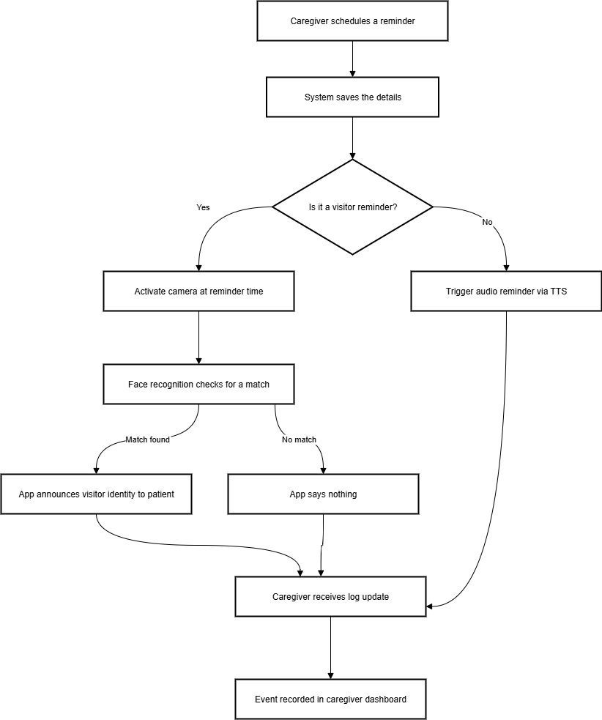
Figure 1. Workflow Diagram of the proposed Alzheimer’s Support System.

System Architecture
The application proposed employs Layered (N-Tier) Architecture, which separates the system into four logical layers, as shown in Figure 1:
- Presentation Layer: The caregiver and patient mobile interface. It handles user operations such as sending voice reminders, posting pictures, and sending reminders.
- Application Layer: This layer carries business logic, such as scheduling reminders, identifying visitors, and enabling module-to-module communication.
- Deep Learning Layer: This layer holds the face recognition model, which compares stored images from caregivers with live camera input.
- Data Layer: Uses a secure cloud database to manage data storage for activity logs, visitor images, caregiver inputs, and reminders.

This layered design enhances maintainability, scalability, as well as future modifications.

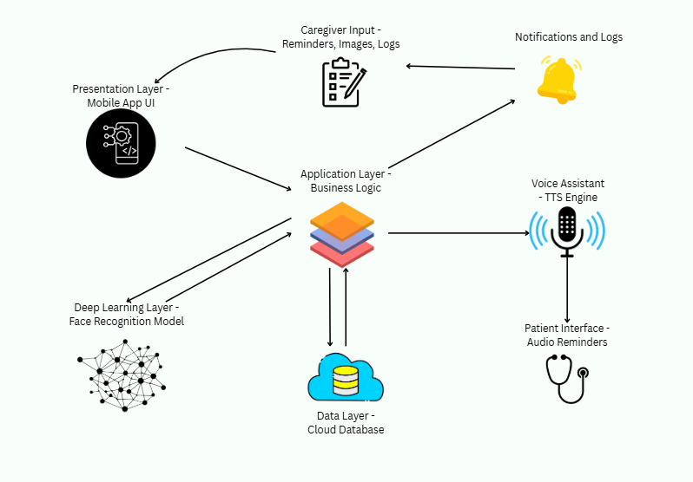
Figure 2. Proposed System Architecture showing the interaction between layers and modules.

Major System Components
The following are the main functional components of the proposed system:
- Caregiver Input Module: Enables caregivers to upload pictures and add, edit, or remove reminders.
- Reminder Management Module: Manages scheduling and timely execution of alerts.
- Camera Input Module: Captures real-time images for recognition.
- Face Recognition Module: Uses an inbuilt machine learning model to compare images.
- Voice Assistant Module: Converts text reminders and recognition results into spoken words for the patient.
- Notification and Logging Module: Records completed events and provides caregivers with activity summaries.

Team Roles and Responsibilities
Here is the breakdown of tasks among group members to ensure the timely completion of the project for the next one year.

Table 2. Individual tasks
Member | Activity | Tentative Date Range
All Members | Initial idea discussion & project planning | Sep-Oct 2025
All Members | Problem statement finalization | Sep-Oct 2025
All Members | Proposal review and approval | Sep-Oct 2025
Wajeeha Aslam | Design and implement reminder system (setting, notifications, voice prompts) | Feb–Apr 2026
Sadia Shakoor | Develop facial recognition module and visitor identification logic | Feb–May 2026
Mutawiffah Mudassar | Build voice assistant (TTS) prototype and initial caregiver dashboard | Mar–Jun 2026
All Members | Testing and debugging individual modules, basic documentation | May–Jun 2026
Sadia & Wajeeha | Integration of reminder system with facial recognition | Sep–Oct 2026
Mutawiffah & Sadia | Integrate voice assistant with notifications and caregiver dashboard | Oct–Nov 2026
All Members | Full system testing, optimization, UI/UX improvements, final documentation | Nov–Dec 2026
All Members | Prepare final report, presentation, and defense submission | Dec 2026

Gangtt Chart

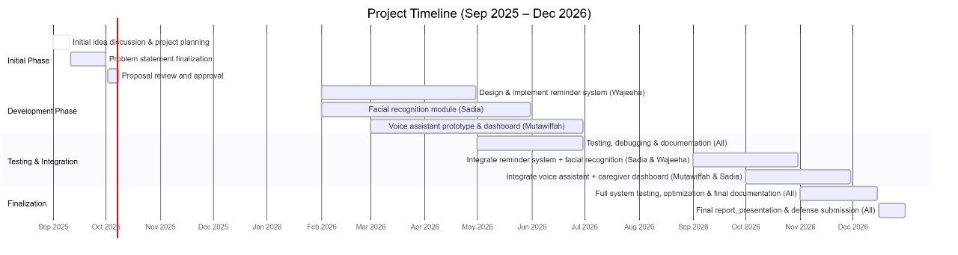
Figure 3. Gantt Chart of Individual tasks of ForgetMeNot

Tools and Technologies
Following are the tools and technologies used.

Technologies
- Dart / JavaScript (TypeScript)
- Flutter / React Native
- Firebase (Cloud Firestore, Authentication)
- SQLite
- OpenCV
- MobileFaceNet / FaceNet Lite (for face recognition)
- Google Speech-to-Text API
- Google Text-to-Speech (TTS)
- Local Notifications API (Flutter Local Notifications / React Native Push Notifications)

Tools
- Visual Studio Code
- Git
- GitHub

Success Criteria
The success of the AI Assistant for Alzheimer’s Patients depends on the following criteria:
- The system provides reliable reminders for medication, appointments, and daily tasks with 100% delivery accuracy.
- The system performs facial recognition of registered visitors with at least 80% identification accuracy under normal lighting.
- The system ensures ease of use, requiring minimal navigation and enabling patients to primarily interact through voice prompts.
- The system provides caregivers with a dashboard to add/edit reminders, upload visitor photos, and view activity logs.
- The system securely stores patient data (reminders, photos, and logs) using Firebase Authentication and Firestore with encryption.
- The system runs stably on mid-range Android devices without crashing during normal operation.
Our goal is to develop the project within the specified timeframe and deliver a solution that improves both patient independence and caregiver support.

References
[1] C. Fang et al., “Impaired holistic processing of facial recognition in patients with Alzheimer’s disease,” Neurology, vol. 94, no. 15_Supplement, 2020.
[2] U. Akare, P. Lonkar, A. Rangari, R. Bhandakkar, and R. Gaikwad, “Research on Assistive System for Alzheimer Patient,” International Journal of Advanced Research in Computer and Communication Engineering (IJARCCE), vol. 14, no. 4, Apr. 2025.
[3] A. Paul, “Wearable Facial Recognition Device for Dementia,” Regeneron ISEF 2023 Project ENBM084.
[4] B. Peres and P. F. Campos, “A systematic review of reminder and guidance systems for Alzheimer’s Disease and Related Dementias: context, barriers and facilitators,” Disability and Rehabilitation: Assistive Technology, 2023.
[5] MIT Media Lab, “Memoro: Wearable Memory Assistant using Personal AI,” ArXiv preprint, 2024.
[6] RAZ Mobility, “RAZ Memory Cell Phone — The Simple Phone for Dementia, Alzheimer’s, And Seniors,” Product Website, 2024.

Appendix A
Turnitin Report:
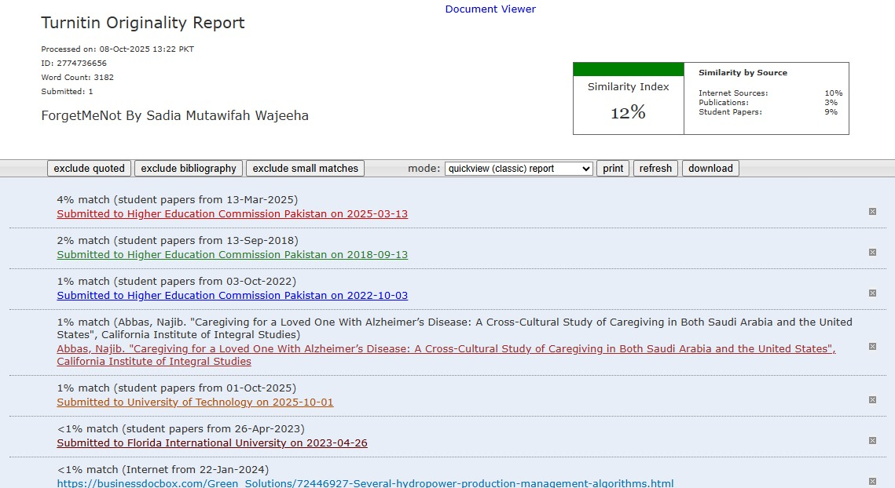
Figure 4. Similarity index report

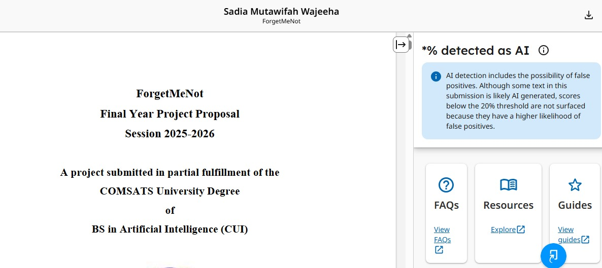
Figure 5. Turn it in report

